Faraway Nearby: Duke and UNC-CH MFA Photography Faculty Exhibition
1 October–16 November 2014

As part of the Click! Triangle Photography Festival, Cassilhaus Gallery hosts an exhibition of the work of six MFA photography faculty at the University of North Carolina at Chapel Hill and Duke University in Durham: Alex Harris, William Noland, and Tom Rankin from Duke, and elin o’Hara slavick, Hồng-Ân Trương, and Jeff Whetstone from UNC.

The exhibition, a first collaboration between the two programs, brings together neighboring colleagues who share an occupation as well as a preoccupation with photography as a means to navigate & transport. In both color and black-and-white prints, the artists traverse geographic and temporal distances, and address – in disparate styles and approaches – the universal dichotomies of the sacred and profane, urban and rural, man and nature. Lisa McCarty and Huston Paschal served as curators for Faraway Nearby.

Works in the Exhibition
Works are lent by the artists unless otherwise indicated.

Alex Harris
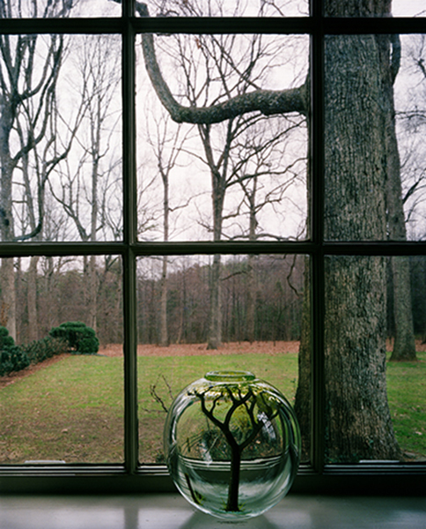

Phil Hanes's House, Winston-Salem, North Carolina, 1983
Pigment print on fiber-base paper.

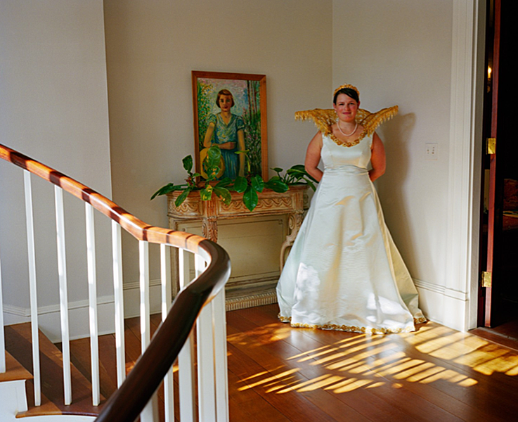

Margaret Langdon Hamilton In Her Mardi Gras Gown, Mobile, Alabama, 2009
Pigment print on fiber-base paper.

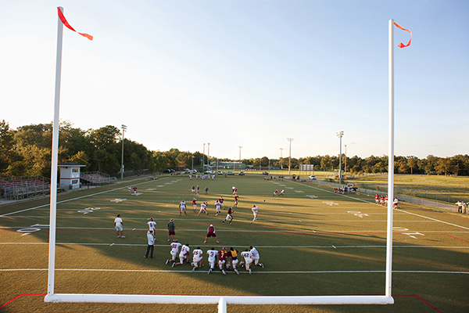

MS-Wright Bulldogs Football Practice,
Mobile, Alabama, 2010
Pigment print on fiber-base paper.

William Noland

About the Series
Images of Images entails an exacting and intimate examination of pre-existing photographic portraits. The images are interrogated both for the metaphysical questions brought on by looking at those who are long since dead as well as for the material changes that time has wrought on the photographic objects in the intervening period through circumstances that are unique to each object.

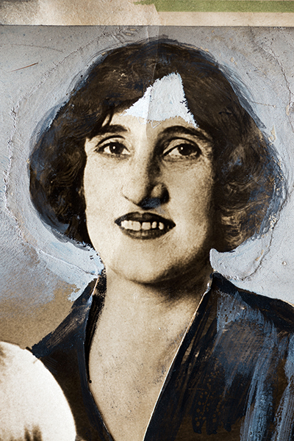

Grimes, 2014
Inkjet print with Ultrachrome archival inks on Hahnemühle photo rag paper.
Detail from an original 1929 manipulated press photo of Callie
Grimes, a Los Angeles madam who was herself arrested after she helped Los Angeles police entrap and arrest Councilman Carl I. Jacobson, a publicity-seeking crusader against vice. Charges against both were later dismissed. White, gray, black, and blue paint detailing.

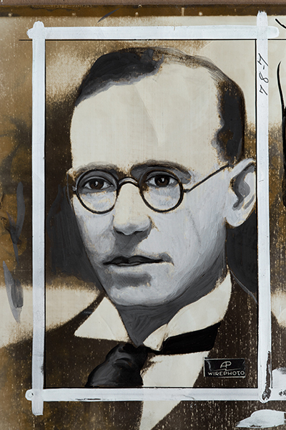

McMahon, 2014
Inkjet print with Ultrachrome archival inks on Hahnemühle photo rag paper.
Detail from an original 1936 manipulated press photo of George Andrew McMahon taken in London. The journalist was arrested when he attempted to shoot King Edward as he returned from a military review. India ink and white, gray, brown, and black paint detailing.

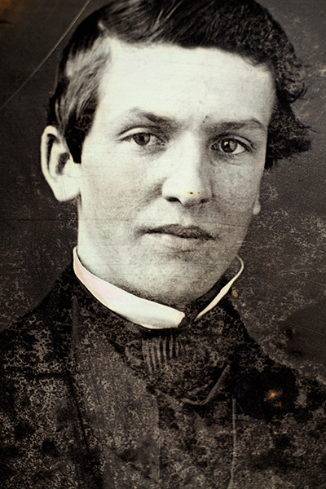

Smith, 2014
Inkjet print with Ultrachrome archival inks on Hahnemühle photo rag paper.
Detail from an original sixth-plate daguerreotype (2¾ x 3¼ in.),
circa 1852, identity of photographer and subject unknown.

Tom Rankin

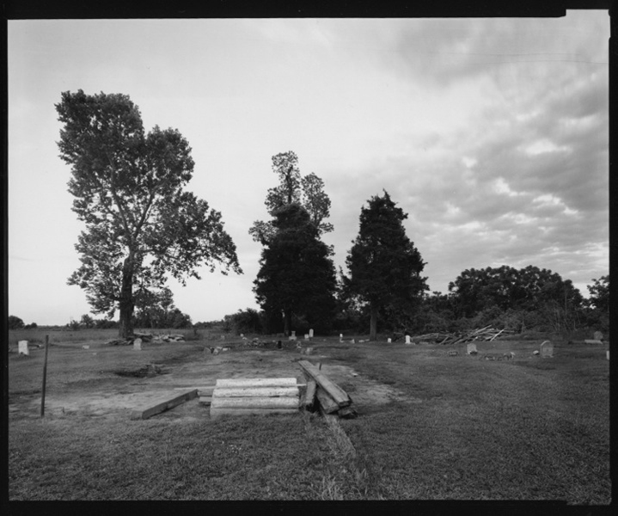

Morning Star MB Church, Beulah, MS, 1997
Toned gelatin silver print

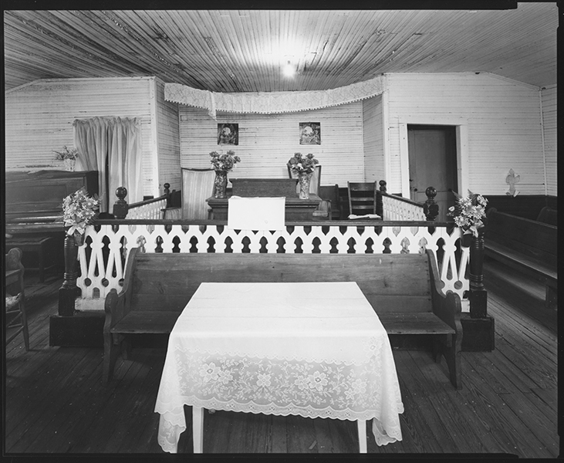

New Hope MB Church, Shelby, MS, 1990
Toned gelatin silver print

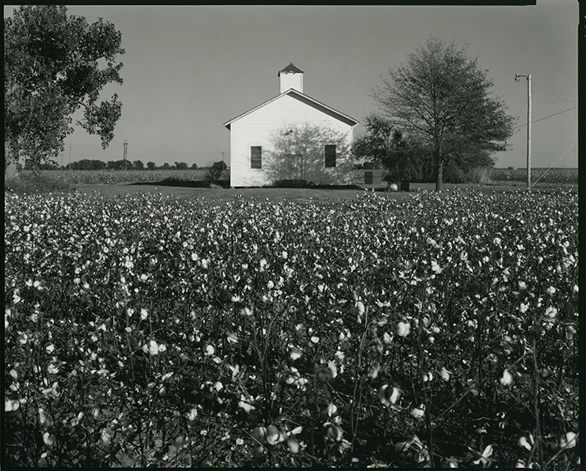

Rolling Fork, MS, 1992
Toned gelatin silver print

elin o’Hara slavick

Gelatin silver contact prints of rubbings of A-Bombed surfaces in Hiroshima, Japan, from After Hiroshima, 2008–2010

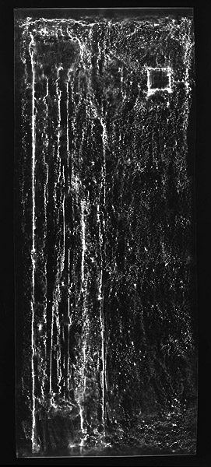

Bank Floor II
The former Nippon Bank stands in the center of Hiroshima, only 300 meters
from the hypocenter. A bank until 1992, it is now a cultural center for exhibitions
where the artist held an exhibition of After Hiroshima in 2011.

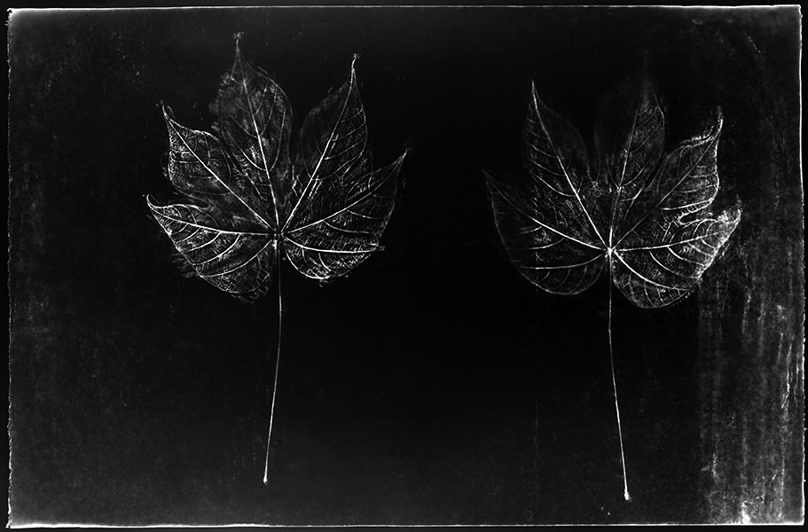

Front and Back of a Leaf from a 2nd Generation
A-Bombed Chinese Parasol Tree

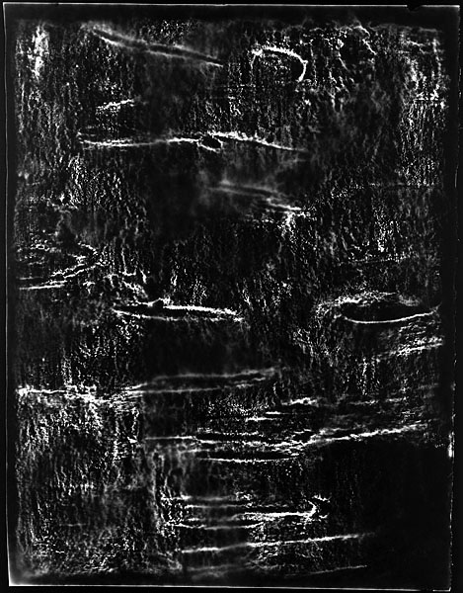

Kurogane Holly Tree

Hồng-Ân Trương

Archival inkjet prints from the series Resistance Can Be Quiet, 2005-2011

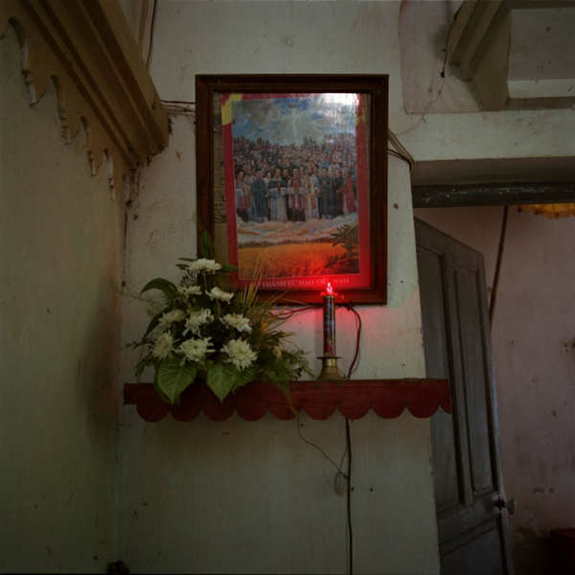

Description #1 (Red Candle)

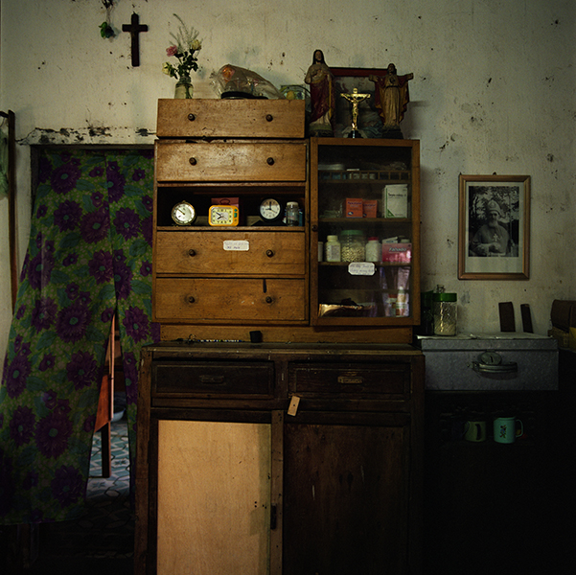

Description #3 (Three Clocks)

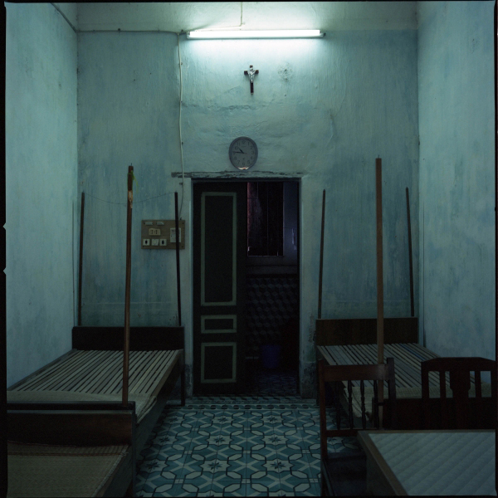

Description #9 (Three Beds)

Jeff Whetstone

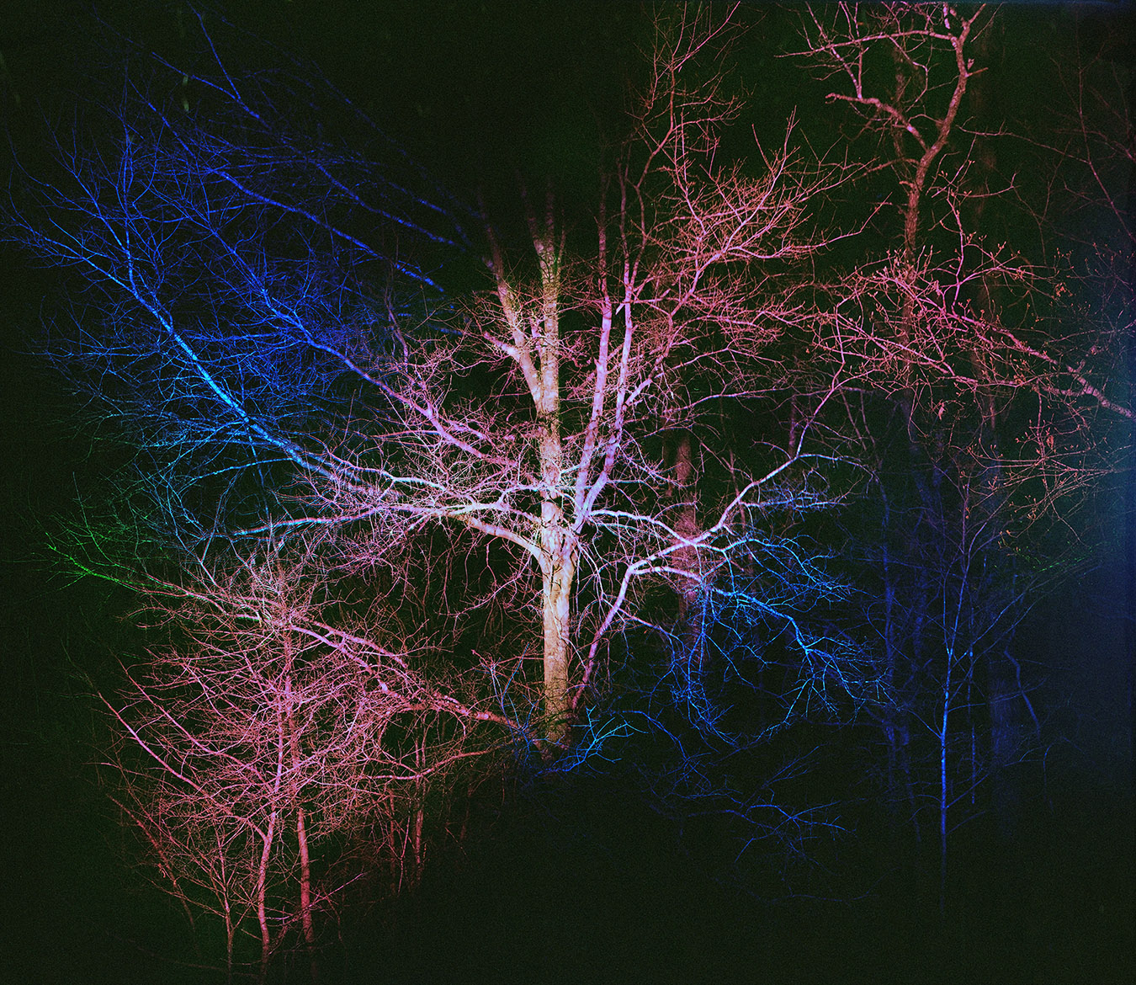

Arbor Spectrum, 2014
Archival inkjet print.
Courtesy the artist and Julie Saul Gallery

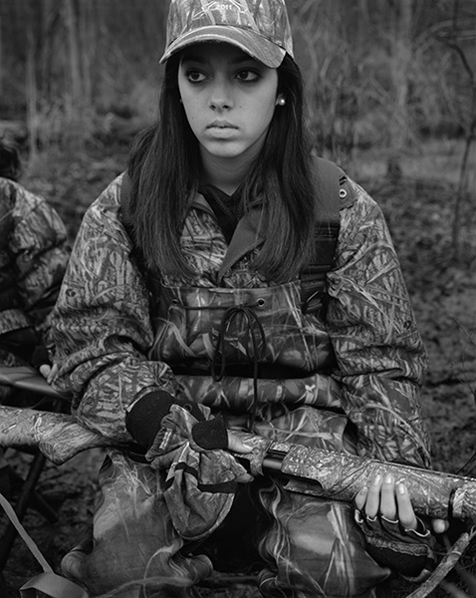

Caitlynn, from New Wilderness, 2013
Archival inkjet print.
Courtesy the artist and Julie Saul Gallery

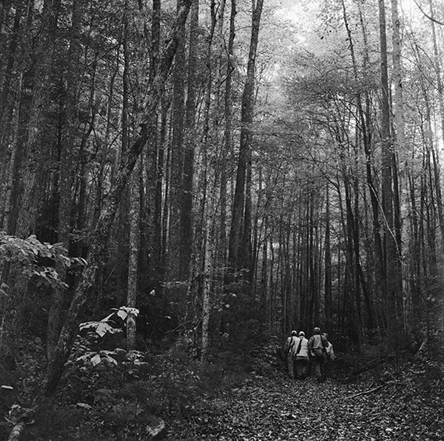

Hunters on Line Fork, from New Wilderness, 1996
Archival inkjet print.
Courtesy the artist and Julie Saul Gallery

Biographies

Alex Harris
Professor of the Practice of Public Policy and Documentary Studies, Duke University, and Creative Director of the Lewis Hine Documentary Fellows Program, at The Center for Documentary Studies
Born 1949, Atlanta, Georgia
After graduation from Yale in 1971, Harris photographed North Carolina as part of a Duke University research project. Between 1972 and 1978 he lived and photographed in Hispanic villages in northern New Mexico and Eskimo villages in Alaska. During these years, Harris also began to commute to North Carolina to teach documentary photography at Duke. In 1980, at Duke, he founded the Center for Documentary Photography, which he directed for eight years. In 1989, he was a founder of its successor, The Center for Documentary Studies. Between 1995 and 1998 Harris launched DoubleTake Magazine with Robert Coles and co-edited the publication through its first twelve issues. Harris’s work is represented in major museum collections, and his awards include a Guggenheim Fellowship in Photography, a Rockefeller Foundation Humanities Fellowship, and a Lyndhurst Prize. As a photographer and editor, Harris has published fifteen books, including River of Traps (with William deBuys) a finalist for the Pulitzer Prize in general non-fiction; The Idea of Cuba; and, most recently, Why We Are Here, a collaboration with E.O.Wilson.

William Noland
Professor of the Practice of Visual Art, Duke University
Born 1954, Washington, D.C.
Noland is a sculptor, photographer and experimental documentary filmmaker. His video work closely relates to the work he has done in other media, particularly the photographic project that intimately examines the individual in public space by isolating moments of psychological resonance within everyday experience. His video imagery extends the still image into a time-based medium by carefully observing and often lingering on individuals. His soundscapes feature richly layered ambient sound and original music. The recipient of a National Endowment for the Arts Visual Artist Fellowship in sculpture, Noland has also received a Fulbright Scholar Award in photography and Josiah Charles Trent Foundation Grants for both photography and video. From 1995-2004 he worked for the highly esteemed quarterly magazine of writing and photography, DoubleTake, first as an editorial advisor and subsequently as a contributing photographer.

Tom Rankin
Professor of the Practice of Art and Documentary Studies and Director of the MFA in Experimental and Documentary Arts program, Duke University
Born 1957, Louisville, Kentucky
A graduate of Tufts University, the University of North Carolina at Chapel Hill, and Georgia State University, Rankin, before coming to Duke, taught at the University of Mississippi and was chair of the art department at Delta State University in Cleveland, Mississippi. For the past 15 years he served as director of The Center for Documentary Studies at Duke. His photographs have been collected and published widely and included in numerous exhibitions. Among his books is Sacred Space: Photographs from the Mississippi Delta, which received the Mississippi Institute of Arts and Letters Award for Photography. Prints from that series are on view in this exhibition. A frequent writer and lecturer on photography, culture, and the documentary tradition, he is the general editor of the Series on Documentary Arts and Culture with the University of North Carolina Press.

elin o’Hara slavick
Director of Graduate Studies for Studio Practice, Professor of Art, UNC-CH
Born 1965, Rochester, New York
After receiving a BA from Sarah Lawrence College, slavick earned an MFA in Photography from the School of the Art Institute of Chicago. She has exhibited her work widely and is the author of Bomb After Bomb: A Violent Cartography, with a foreword by Howard Zinn and essay by Carol Mavor, and After Hiroshima, with an essay by James Elkins. The prints in this exhibition come from the After Hiroshima series. She is also a curator, critic, and activist.

Hồng-Ân Trương
Assistant Professor, UNC-CH
Born 1976, Gainesville, Florida
Trương received an MFA from the University of California, Irvine, after which she was a studio fellow in the Whitney Independent Study Program. An interdisciplinary artist and writer who often collaborates with her students on projects, she has shown her work at various venues in New York and elsewhere. Art Matters Foundation awarded her a grant, and she was a recent recipient of a Jerome Foundation Fellowship at Franconia Sculpture Park.

Jeff Whetstone
Associate Professor, UNC-CH
Born 1968, Chattanooga, Tennessee

Whetstone has been photographing and writing about the relationship between humans and their environment since his undergraduate days. He received a Zoology degree from Duke University in 1990 and in 2001 earned an MFA in photography from Yale University. In 2007, Whetstone won a Guggenheim Fellowship for a body of photographs entitled New Wilderness. Two works from this series are on view here. The following year he received the first Factor Prize for Southern Art. Whetstone also works in video, animation, and 16mm film. He was a 2012 recipient of a North Carolina Artists Fellowship in film. Whetstone is one of three North Carolinians whose work is included in State of the Art: Discovering American Art Now, currently at the Crystal Bridges Museum of American Art.

Project Gallery

John Menapace (1927-2010) made gelatin silver prints from the 1960s to the late 1980s. The fourteen in this exhibition, all untitled, were made in the decade between 1975 and 1985.

Menapace, instrumental in gaining recognition for photography as an art form, taught an entire generation of photographers in the state, many of them at UNC and Duke. His work, including a number of self-portraits, is the subject of Smokes and Mirrors: Reflections of the Self in Photographs by John Menapace, a much larger exhibition in the Click! Festival at the Gregg Museum of Art and Design at NCSU.

Lenders
Cassilhaus Collection: 4 (1980), 5 (1982), 6 (1976), 9 (1975), and 14 (1976)
Sammy Kirby: 1 (1980), 7 (1979), 11 (1975), 12 (1983), and 13 (1981)
Huston Paschal: 2 (1984), 8 (1983), and 10 (1980)
David Simonton: 3 (1985)

